Research Experience Placement (REP) Scheme 2023
Supervisor Project Proforma
Project title: | Developing the UK Observational Network to Monitor Progress Towards Net Zero
Host Institution: | National Centre for Earth Observation, University of Leicester
Project supervisor (name, department): | Dr Robert Parker, National Centre for Earth Observation
Project enquiries (supervisor email): | rjp23@le.ac.uk
Co-Supervisor, if any (name, department): | Dr Neil Humpage  (National Centre for Earth Observation, University of Leicester)
Proposed start date: | 1st July 2023 onwards (flexible)
Project description:
Anthropogenic greenhouse gas emissions, mainly carbon dioxide (CO₂) and methane (CH₄), have been identified as the primary drivers of climate change. In response, the UK government has committed to achieving net zero emissions by 2050, with a 78% reduction in greenhouse gas emissions by 2035. Achieving this ambitious target requires robust monitoring of atmospheric CO₂ and CH₄ concentrations to accurately quantify the sources and sinks of these gases, and to track progress towards decarbonisation goals.

Measurements of atmospheric composition will play a key role in understanding the UK's progress towards net zero carbon emissions. The National Centre for Earth Observation is in the process of establishing a new, state-of-the-art, nationwide network of ground-based remote sensing instruments that will monitor greenhouse gas concentrations over the UK (GEMINI-UK). With £1.4m of government funding, the network will become a crucial interface to current and future satellite instruments that measure atmosphere GHGs, which will eventually play a role in verifying UK GHG emissions.

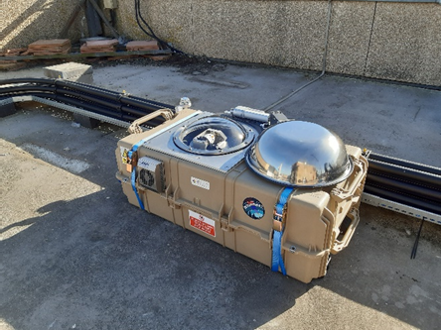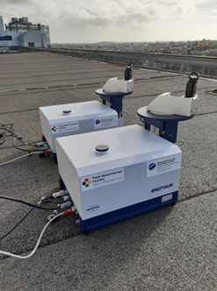
Figure 1: The Bruker EM27/SUN instrument within its automated weatherproof enclosure (left); two EM27/SUNs without enclosures (right).

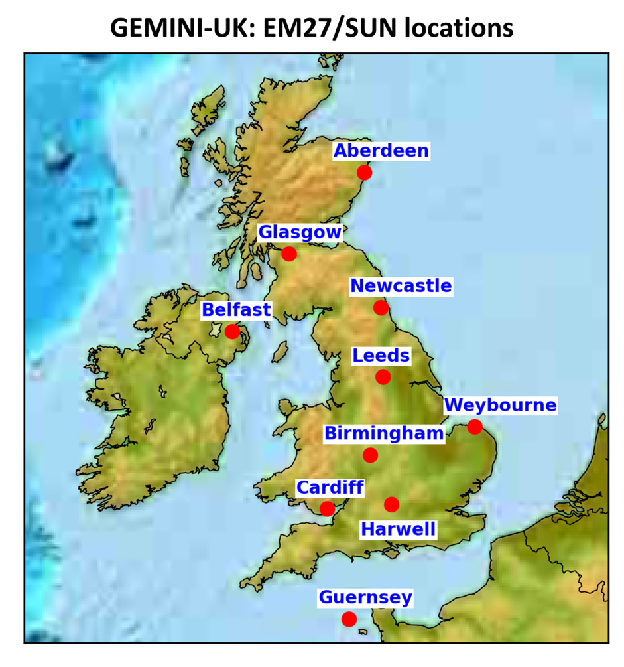
Figure 2: Proposed locations of the ten new EM27/SUN instruments that form the GEMINI-UK network, which will come online during summer 2023.

The aim of this project is to explore the potential added value of the GEMINI-UK network by undertaking analysis of existing ground-based GHG observations and performing simulations to characterise the signals we may expect to observe from the new network.

Working at Space Park Leicester, the candidate will be involved in testing one of the GEMINI-UK EM27/SUN instrument and enclosure systems. The testing will take place before deployment at one of the network sites, allowing the candidate to gain a comprehensive understanding of the instruments' functionality and data processing techniques.

The project includes analysis of data obtained from similar measurement systems used during the DARE-UK project, which were positioned at three sites across London. The aim is to identify and explain the enhanced atmospheric concentrations of CO₂/CH₄. The candidate will also use atmospheric transport model simulations and existing emissions inventories to predict the expected signals that the GEMINI-UK network should detect at various measurement locations.

Potential project extensions comprise further testing of GEMINI-UK EM27/SUN systems in Leicester, assisting in the deployment of the GEMINI-UK EM27/SUN systems at their designated sites, and using DARE-UK data to evaluate the accuracy of models and satellites in measuring the gradients in atmospheric concentrations of greenhouse gases over London.

This project offers the candidate the opportunity to develop skills and knowledge related to:
- The importance of monitoring Net Zero
- Performing ground-based atmospheric observations
- Accessing and using satellite remote sensing data and environmental model data
- The use of High-Performance Computing for environmental science
- Using machine-learning methods to analyse climate and remote sensing data

The candidate will be supervised by Dr Robert Parker, a research fellow for the National Centre of Earth Observation, based at Space Park Leicester. Dr Parker is an expert on climate change, in particular relating to greenhouse gas measurements, and is currently leading a range of activities focused around Carbon-Climate interactions. Dr Neil Humpage will co-supervise the project. Dr Humpage is the Science Manager for the GEMINI-UK network and an expert in atmospheric observations and instrumentation.

Project timeline:
Project Duration: 6-10 weeks

The minimum length of the project will be 6 weeks but the project objectives are flexible and could accommodate a candidate for between 6 and 10 weeks over Summer 2023.

Weeks 1-2: Work on testing of one of the GEMINI-UK EM27/SUN instrument and enclosure systems at Space Park Leicester, prior to deployment at one of the network sites. This will allow the candidate to gain an understanding of how the instruments work and how to process the data.
Weeks 3-4: Analysis of pre-existing data taken using similar measurement systems during the DARE-UK project, which were situated in three locations across London, to identify and explain enhanced atmospheric concentrations of CO₂/CH₄.
Weeks 5-6: Work with atmospheric transport model simulations and existing emissions inventories to determine the expected signals that we may observe at the different measurement locations in the GEMINI-UK network.
Weeks 7+: Potential extensions to the project include: further testing of GEMINI-UK EM27/SUN systems in Leicester prior to their deployment elsewhere; assistance with deployment of the GEMINI-UK EM27/SUN systems at their designated sites; using the DARE-UK data to assess the ability of models and satellites to calculate or observe gradients in atmospheric concentrations of greenhouse gases over London.

Candidate requirements:
This project would suit a candidate either with prior knowledge of the Python programming language or one who is keen to learn.

Part of the project is expected to be lab-based and part is expected to be computational, but this can be flexible depending on the successful candidate.

The candidate would ideally be located at Space Park Leicester for some of the project duration (particularly the lab-based aspects) but we are flexible in relation to remote working should that be necessary.

Background reading and references:
Net Zero Strategy: Build Back Greener, ISBN 978-1-5286-2938-6,
https://www.gov.uk/government/publications/net-zero-strategy [accessed 13/10/2022]

Fankhauser, S., Smith, S.M., Allen, M. et al. The meaning of net zero and how to get it right. Nat. Clim. Chang. 12, 15–21 (2022). https://doi.org/10.1038/s41558-021-01245-w

To be completed by institutional CENTA PoC
I confirm that:
- Appropriate supervisory arrangements are in place
- Any necessary ethical committee approvals, animals licences & requirements of regulatory authorities will be in place before the work begins and will be maintained for the duration of the project
- We will take responsibility for identification, protection & exploitation of any intellectual property rights arising from the project
- All facilities, agreements regarding access and collaborations necessary for the work will be obtained before the work commences and can be ensured for the duration of the project
- All costs awarded by NERC for the REP will be used and accounted for appropriately
- A report of the project by the student will be submitted no later than one week after the end date of the placement or 15th September 2023, whichever falls first.

Signed: 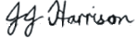
Date: 4 May 2023
Position: CENTA PoC for NCEO

