Research Experience Placement (REP) Scheme 2024
Supervisor Project Proforma
Project title: | Evaluating the role of algal blooms in aquatic carbon flux at Rutland Water Nature Reserve
Host Institution: | Loughborough University
Project supervisor (name, department): | Savannah Worne, Geography and Environment
Project enquiries (supervisor email): | s.worne@lboro.ac.uk
Co-Supervisor, if any (name, department): | Helen Glanville, Geography and Environment
Proposed start date: | 1st July 2024
Project description (max 700 words, 1-2 figures may be included):
Proposed projects must:
- have a clearly defined objective
- be within the science remit of NERC
- be feasible for a student to complete within the timescale of the placement
- include more than purely a computer/modelling component i.e., some element of fieldwork, data collection, activity to give an understanding of the wider context including participation in lab/team meetings, networking and training etc.
- give scope for thought and initiative on the part of the student and should not use the student as a general assistant
- be based at an eligible UK research organisation (remote placements are also an option for enabling inclusivity).

The sustainability of water resources and natural habitats is threatened by algal blooms, which cause issues with water quality, and significantly alter the function, structure and unique biodiversity of these ecosystems. This is particularly true of standing waters which have slower flushing rates, and so accumulate nutrients that fuel algal blooms. Primary producers including algae require a significant amount of carbon to grow, hence longer and more pervasive algal blooms may increase carbon drawdown. However, little is known about the composition and seasonality of organic carbon produced by algae¹. Research indicates the toxicity of algal blooms can change the release of methane (Fig. 1) which will also impact carbon cycling, as well as driving wider ecosystem impacts (such as reducing oxygen levels)². Future climate change is likely to enhance algal blooms, however it is unclear what impact this will have on carbon cycling. There is an urgent need to better understand the role of algal blooms in carbon cycling in standing water systems to better evaluate whether the potential carbon drawdown outweighs the wider ecosystem impacts of algal blooms.

This study will be undertaken at Rutland Water (RW), which is one of the UK’s largest drinking water reservoirs. This reservoir provides an essential regional water supply and supports the adjacent Rutland Water Nature Reserve (RWNR) which is composed of 8 shallow water lagoons. RW hosts >25,000 birds annually, including 10 internationally protected species, granting it multiple designations as an internationally protected site. However, Oakham sewage treatment works (STW) has an effluent discharge point which feeds directly into one of the lagoons (Lagoon 3; Fig 2), which in turn has a managed pipe-connection to the main reservoir. Natural England have identified this STW as a key source of nutrient pollution³; as lagoons become enriched with these nutrients, they shift from clear waters dominated by submerged macrophytes to turbid waters dominated by algal blooms, particularly which reduces food and habitat availability for key bird species. Preliminary ecological data from 2023 demonstrated higher abundance of cyanobacteria (including M. aeruginosa), including large algal blooms occurring in Lagoon 3, which were not present in lagoons which are not impacted by the sewage inflow.

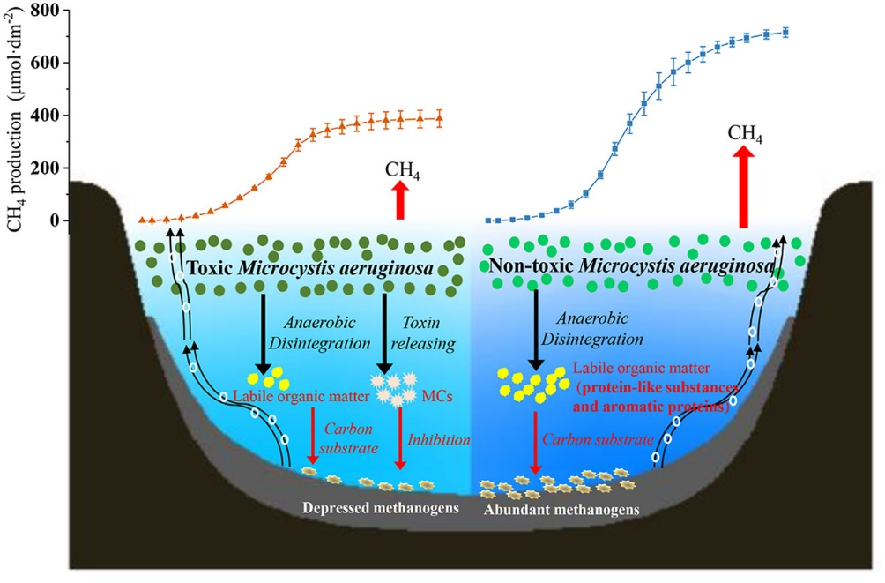
Figure 1) Graphical abstract of Xu et al., (2020), demonstrating how the toxicity of algal blooms (M. aeruginosa., which is found in Lagoon 3 at RWNR) alters methane cycling.

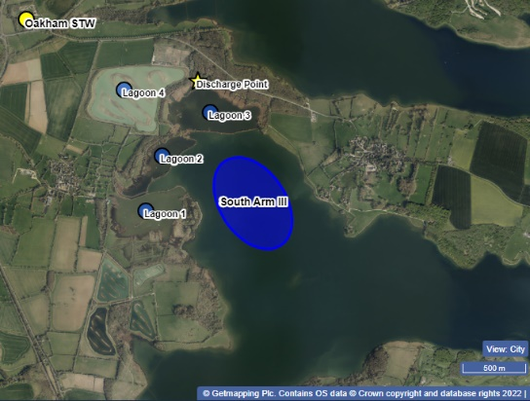

Figure 2 Map of central sector of Rutland Water Nature Reserve
Through analysis of chlorophyll-a content and total organic carbon (TOC) content of water samples collected from May 2023 to July 2024, this project will be the first quantitative evaluation of how significantly algal blooms contribute to carbon flux over an annual cycle, in relation to different human pressure (i.e. nutrients from sewage, agriculture, or reservoir). This will be achieved through the following:

- Laboratory analysis for chlorophyll-a concentrations of samples collected from May 2023 to June 2024, using a spectrophotometer. Results will indicate total algal productivity.
- Laboratory analysis of TOC content of water samples collected from May 2023 to June 2024, using a TOC analyser, and will be indicative of carbon flux.
- A one-day field visit to RW in early/mid July to collect additional samples for both chlorophyll-a and TOC analysis. This will include sampling from a boat and from the bankside.
- Comparison of annual chlorophyll-a and TOC data between sites, in line with other data collected by supervisor, to evaluate the role of algal blooms in carbon cycling under different anthropogenic pressures.
- Optional: Taxonomic identification of phytoplankton samples using light microscopy from summer 2023, and fresh samples collected in July 2024.

The research undertaken by the student will contribute to a wider body of research at RWNR undertaken by the Dr. Worne, which is evaluating the variability in water and ecological quality across the whole site. Data from this study will feed into publishable research, which the REP student is encouraged to collaborate on after the placement. Results will provide evidence to the Leicestershire and Rutland Wildlife Trust, and Anglian Water, who co-manage the site, about the nature of algal blooms at the site, and be used to inform further study around water quality management practices.

Project timeline:
Week 1:
- Health and Safety briefing and lab induction, familiarisation with lab and methods.
- Undertake sample inventory and design a schedule of work that meets project scope and student ambitions.

Weeks 2/3, 4 and 5:
- Laboratory analysis of waters for chlorophyll-a and TOC, following student-designed schedule. Total number of samples will be 96 for each analysis.
- Optional: Prepare samples for phytoplankton assemblage analysis, familiarization/training in phytoplankton taxonomy and microscopy.

Weeks 2/3:
- One day field visit to Rutland Water for water sample collection (date TBC). This will include out of hours work after fieldwork to filter and preserve samples for subsequent analysis (total number = 8 samples).

Week 6:
- Outputs of the student project should be a short report, that contextualises results within the literature, from similar shallow water systems.

Candidate requirements:
Essential:
- Interest in working in a laboratory environment, learning new methods and running laboratory equipment. This will include working flexibly alongside the laboratory technicians.
- Be willing to undertake repetitive tasks, including cleaning of equipment between/after use.
- Ability to work on campus at Loughborough for the duration of the project.
- Interest in aquatic environmental science/ecology/climate change.
- Strong organisational and time management skills. Ability to work independently and pay attention to detail.

Desirable:
- Experience working in a laboratory environment.
- Interest in developing research outcomes into publishable research.
- Experience working in/near water.

Background reading and references:
1. Du, Y. X. et al. Production and transformation of organic matter driven by algal blooms in a shallow lake: Role of sediments. Water Res 219, 118560 (2022).
2. Xu, H. et al. Methane production in harmful algal blooms collapsed water: The contribution of non-toxic Microcystis aeruginosa outweighs that of the toxic variety. J Clean Prod 276, (2020).
3. Natural England. Site Improvement Plan Rutland Water. (2014).

Other useful background reading for a similar project:
Cross, Iain David (2009). The effects of nutrients and hydrology on shallow lake plankton at Attenborough Nature Reserve, Nottinghamshire. PhD thesis, University of Nottingham.

To be completed by institutional CENTA PoC
I confirm that:
- The host institution takes responsibility for selecting a suitable undergraduate student and ensuring eligibility (see NERC REP student eligibility requirements above) and confirming their eligibility using the UKRI criteria listed under the NERC REP student eligibility criteria
- This REP project falls within the NERC remit and is of suitable quality
- Appropriate supervisory arrangements are in place
- The student recruited to undertake this placement will have a PhD student mentor from the DTP/CDT
- The application processes used will be inclusive and accessible
- Reasonable adjustments will be made for students that need them whilst undertaking placements
- The placement will be carried out in accordance with all applicable ethical, legal and regulatory requirements including but not limited to relevant provisions of the General Data Protection Regulation, the Data Protection Act 2018, the Bribery Act 2010, the Fraud Act 2006, the Equality Act 2010 and the Modern Slavery Act 2015
- The host organisation takes responsibility for identification, protection and exploitation of any intellectual property rights arising from the work
- All facilities, agreements about access and collaborations necessary for the work will be obtained before the work commences and can be ensured through the period of the work
- All costs awarded by NERC for the REPs will be used and accounted for appropriately
- A report of the project by the student will be submitted no later than one week after the end date of the placement or Friday 27th September 2024, whichever falls first.

Signed: 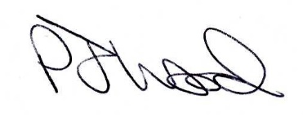
Date: 3rd May 2024 03/05/2024
Position: Prof Ecohydrology and Physical Geography
Loughborough University Point of Contact.

